DBMS ASSG – 8 B191143CS

PANASA TEJA

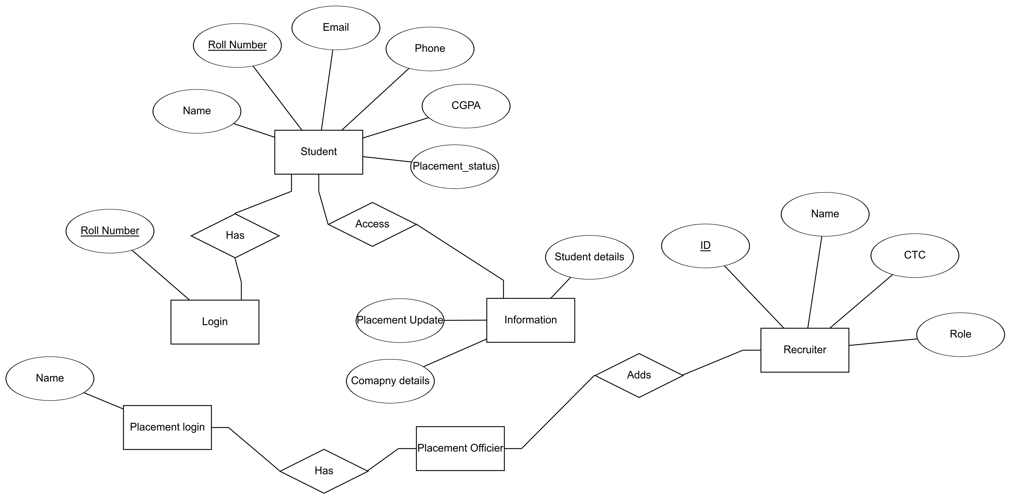

Student

Name | Roll Number | Email | Phone | CGPA | Placement Status
Teja | B191143CS | 12@gmail.com | 9550921397 | 8.13 | Not Placed

Login

Login Roll Number
B191143CS

Placement Login

Name | ID
Officer1 | O19111EP

Recruiter
ID | NAME | CTC | ROLE | OFFICER ID
O19111EP | Officer1 | 30L | SDE | FF3235W

Placement Officer

OFFICER ID | NAME
FF3235W | Officer1

Information

Roll Number | Officer ID | Details | Company | Update
B191143CS | FF3235W | Placed | Amazon | -

Every table is in Normalized from

1NF – All the data is in tables
2NF – No Partial Dependency (proper Subset of Candidate key will determine Non- prime attribute)
3NF – Any One of the conditions need to satisfy
(I) L. H. S – Super Key
(II) R.H.S – Prime Attribute
BCNF- L. H .S – Super Key

The Created DataBase with GUI using JDBC( Java Data Base Connectivity)
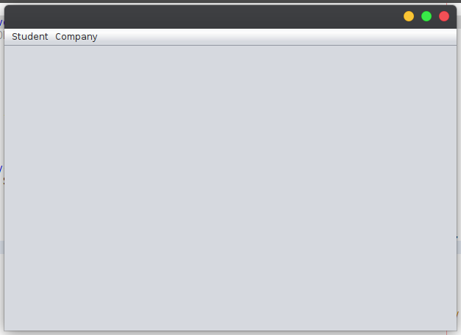

Placement Officer can add company details to the students
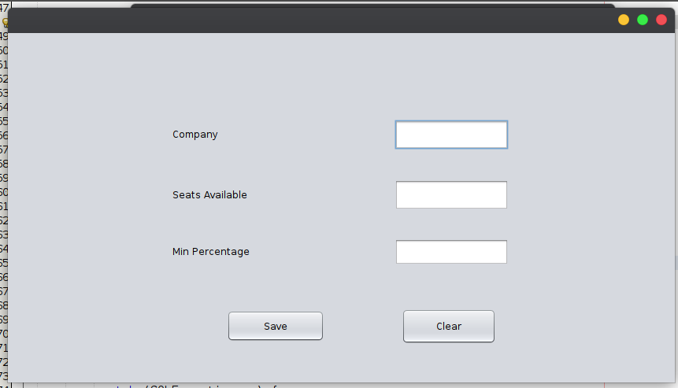

Student Registration Portal
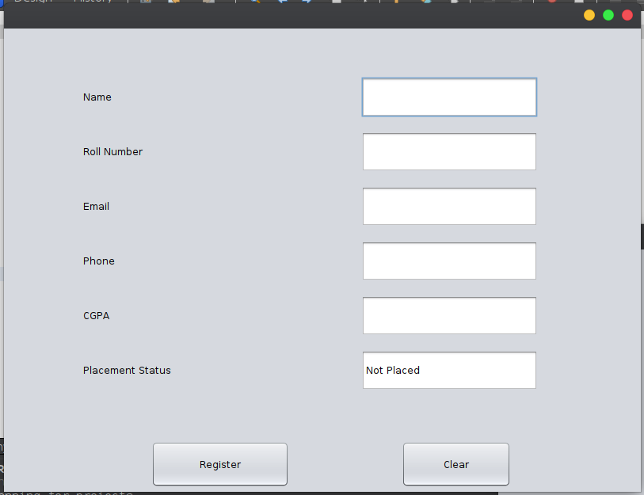
Used for Editing Student Details as well as Delete Student Record

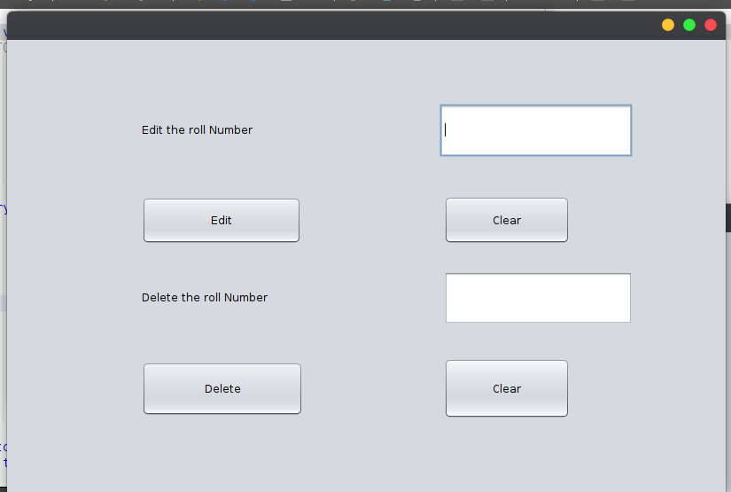

Show the list of students

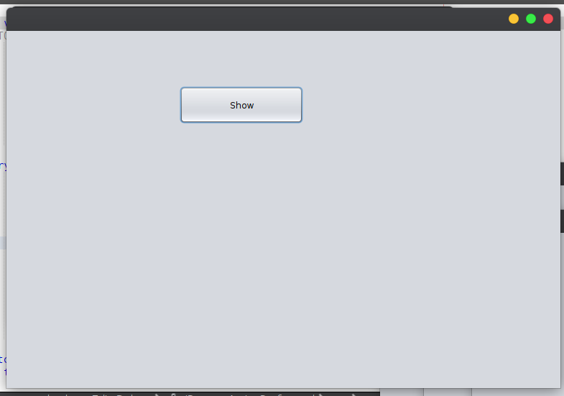

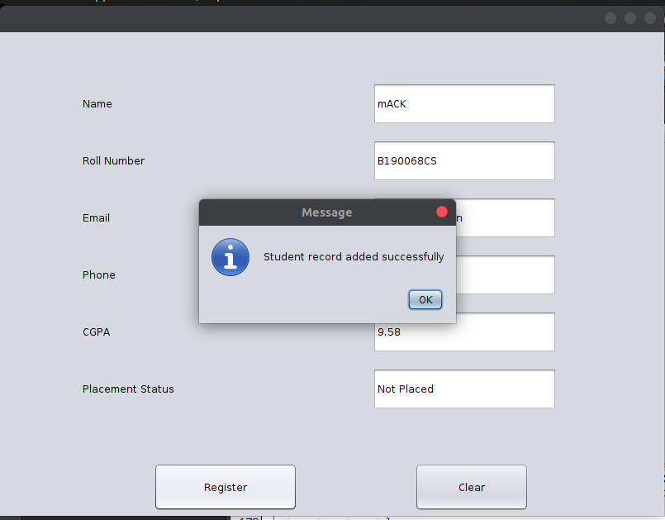
After adding student record successfully

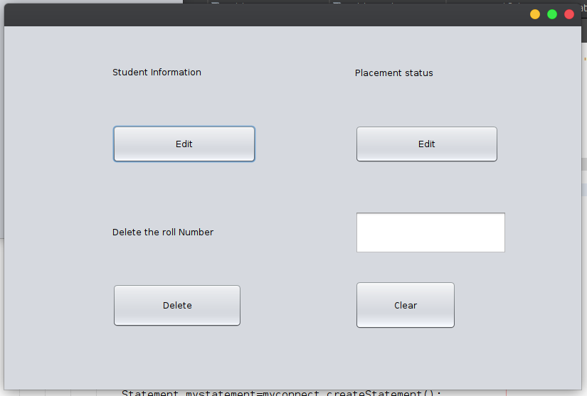

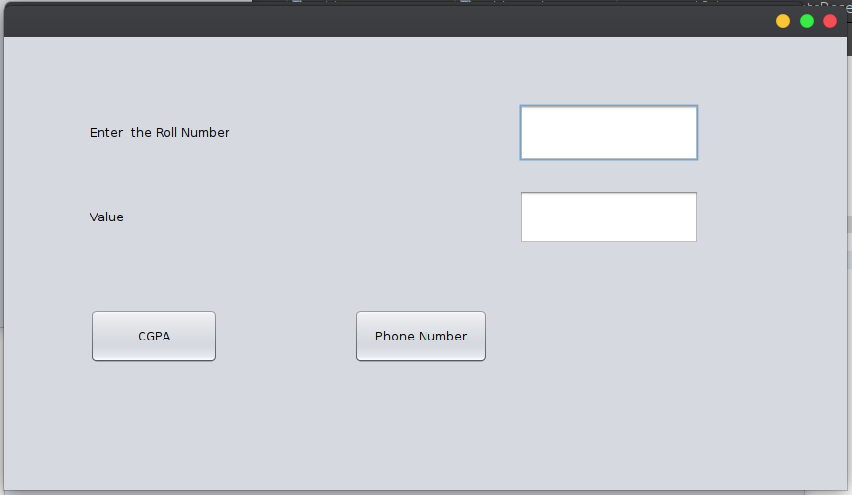
Updating Student Record

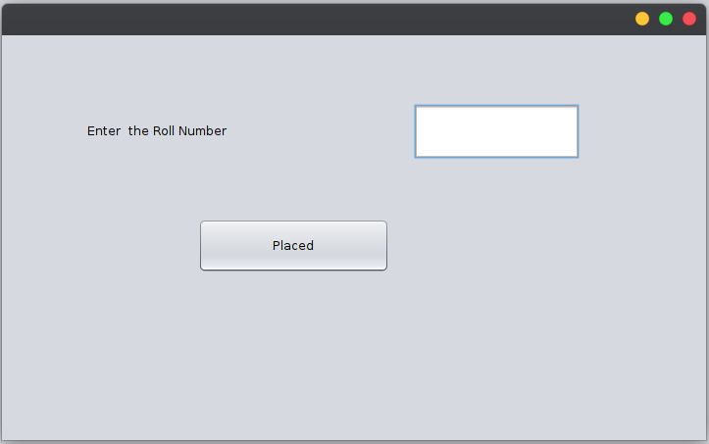
Placement Officer Only can edit the status of the students

